UNIVERSITY COLLEGE DUBLIN
Withdrawal Form (Retrospective Applications Only)

Withdrawal is where a student leaves their programme of study permanently and ends all activity associated with their studies before they have completed the programme for which they are registered.

Before completing and submitting the form (online or paper) you are strongly encouraged to seek support and advice from your Programme Office/School Office/Graduate School Office in the first instance in relation to your options.¹ You are also advised to read the UCD Withdrawal Procedure which can be accessed at http://www.ucd.ie/registry/academicsecretariat/wd.htm and make yourself aware of the implications for you of withdrawing from a programme e.g. fees implications, campus entitlements..

Since 1 August 2016, the standard withdrawal form has moved to SISWeb and can be accessed under ‘Programme Services’ and ‘My Leave of Absence/Withdrawal Requests’. This online form should be used unless your application is retrospective; you will need to use this paper form for when making an application for a retrospective programme withdrawal.²

Please return your student card to your Programme Office or School Office.³

Your confidentiality is assured. Only those people who will consider and process your form will have sight of this form.

It is important that you submit the form as soon as possible as you may remain liable for fees up to the date you formally submit this completed form to your Programme Office/School Office.⁴

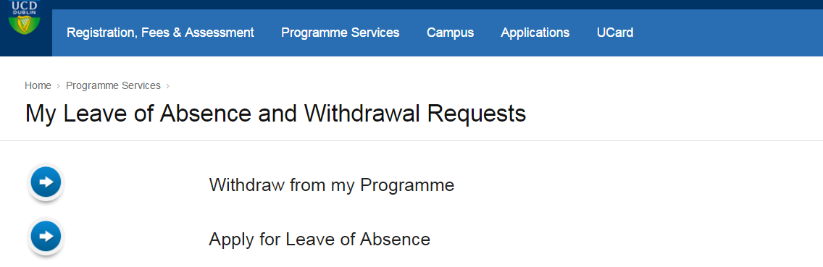

Students complete Sections A – C. Section D is completed by the Principal Supervisor and Head of School (for retrospective withdrawal applications from graduate research students only) and Section E is completed by the Programme Office/School Office.

Notes
¹ While your Programme Office/School Office/Graduate School Office is your primary point of contact, you can also find a current list of UCD support systems at http://www.ucd.ie/students/studentsupport.html.

² A retrospective application for withdrawal will only be granted by the Programme Board/Graduate Board in accepted extenuating circumstances cases where there is no other available solution for the student given their circumstances and where the student has not been engaged in any programme activity. In all retrospective applications, appropriate original supporting evidence must be supplied e.g. medical certificate. Please refer to the Guide on Completing the Withdrawal Form, http://www.ucd.ie/registry/academicsecretariat/wd.htm, for further information on what is accepted as appropriate original supporting evidence.
NOTE: original supporting documentation is not returnable. It is recommended that you retain a copy of the application for your records.

³ All student cards (and paper forms) from students on undergraduate programmes are submitted to their Programme Office and student cards (and paper forms) from students on graduate programmes are submitted to their School Office/Programme Office.

⁴ Information on the fees’ implications of retrospective withdrawal can be found on the Current Students website at http://www.ucd.ie/registry/adminservices/fees/withdrawing_from_a_course.htm and information on refunds can be accessed at http://www.ucd.ie/registry/adminservices/fees/refunds.htm.

- PERSONAL and PROGRAMME DETAILS
Student Name
Student number |  |  |  | Telephone number
E-mail Address
Permanent Postal Address
Programme Title and Code
- REASON(S) FOR WITHDRAWAL
The University would be interested in learning the reason(s) for your withdrawal from your programme of study at UCD. NOTE: retrospective applications must be accompanied by appropriate original supporting evidence e.g. original medical certificate. Please refer to the Guide on Completing the Withdrawal Form for further information.

Use an additional page appended to this form if necessary.

Your confidentiality is assured. Only those people who will process your form will have sight of this form.
Remember, you can also find a current list of UCD support systems at http://www.ucd.ie/students/studentsupport.html.

Please specify the date you would have submitted your withdrawal if you had not been prevented from doing so by extenuating circumstances.
Date:

Please tick this box if you do not wish to be contacted by the University for an exit interview.
- STUDENT DECLARATION AND SIGNATURE
Please note that notification forms cannot be accepted where a student does not sign the form here at Section C.
I confirm that I am aware of options available to me other than withdrawal and that I have read and understood the UCD Withdrawal Procedure ( http://www.ucd.ie/registry/academicsecretariat/wd.htm ) and other relevant documents, e.g. Leave of Absence Academic Policy (www.ucd.ie/leaveofabsence), Policy on Extenuating Circumstances ( http://www.ucd.ie/registry/academicsecretariat/extc.htm).

The information given in this form is true and factually correct. I confirm that this information may be disclosed, where necessary, to academic and administrative staff of the University involved in determining and implementing my request.

Signed: ________________________________________ Date: ______________________

- ADDITIONAL SIGNATURES REQUIRED (For retrospective withdrawals from graduate research students only)
The following additional signatures are required.
In signing the completed form, the Principal Supervisor and Head of School are indicating their approval of the application.
Principal Supervisor:
Head of School:
- FOR OFFICE USE ONLY
- RECEIVED BY THE PROGRAMME OFFICE/SCHOOL OFFICE

Office: _______________________________________

Received by: __________________________________ Date of submission: _______________

Student card handed in: YES ___ NO ___
(This form, and returned student card should be sent to UCD Registry (Registration and Records Office) unless a retrospective application is submitted. A photocopy of the form when it has been signed and dated by the Programme Office/School Office should be given to the student.)

This withdrawal will be noted/considered at the next Programme Board/Graduate School Board.

- DATE SENT TO THE GRADUATE SCHOOL OFFICE (File copy) [For retrospective applications only]
Office: Date:

Signed: Print name:

- DECISION OF THE PROGRAMME BOARD/GRADUATE BOARD [For retrospective applications only]

Application approved: YES NO

Date of decision:

Effective date of withdrawal:

Delegated Authority:
Date Registry informed of the withdrawal (File copy)

